Sustar PeptiMax
High-Digestibility Functional Soy Protein
High-Protein Fermented Plant Protein · Functional Yeast Culture
High-Digestibility Fermented Plant Protein – A Cost-Effective Alternative to Fishmeal, Yeast Hydrolysate, and Premium Fermented Plant Proteins

I. Product Positioning
Sustar PeptiMax is a high-digestibility functional soy protein produced from high-quality soybean meal as the substrate, through a proprietary process involving deep aerobic fermentation with Saccharomyces cerevisiae, high-temperature conditioning, enzymatic hydrolysis, aerobic fermentation, extrusion puffing, and low-temperature drying.
Compared with conventional fermented soybean meal and single-ingredient yeast cultures, this product delivers dual value as both a high-digestibility fermented plant protein and a functional yeast culture.
As a high-digestibility fermented plant protein, it can partially replace fishmeal, yeast hydrolysate, and premium fermented plant proteins
Applicable Animals
Primarily suitable for premium aquaculture species such as shrimp, grouper, sea bass, yellow catfish, mandarin fish, salmon, and eel, as well as young terrestrial animals like piglets.

II. Production Process

2.1 Process Flow
High-temperature conditioning → Enzymatic saccharification → Yeast inoculation → Aerobic fermentation → Yeast autolysis → Extrusion puffing → Low-temperature drying → Packaging

2.2 Key Process Control
Process | Parameter / Function
High-temperature conditioning | 90°C, 20 min; it will sterilize raw materials, eliminate microorganisms, reduce contamination risks during fermentation, and improve product stability
Enzymatic saccharification | Glucoamylase, mannanase etc. are used to pretreat carbohydrates to control fermentation loss and remove oligosaccharides
Aerobic fermentation | Shallow-layer aerobic fermentation with yeast: vigorous cell growth and high cell counts; abundant aerobic and anaerobic metabolites; raising substrate consumption, thereby concentrating protein
Extrusion puffing | Soybean globular protein is modified into a loose fibrous structure for better water-holding capacity and digestibility
Low-temperature drying | Since the fermentation has already consumed the monosaccharides in soybean meal, the Maillard reaction during drying is significantly reduced, enhancing digestibility; low temperature maximizes retention of bioactive substances

2.3 Constant‑Temperature Purified Fermentation Workshop
Proprietary strains, multi‑strain combination, purified workshop, constant‑temperature fermentation, uniform fermentation, and fully automated operation ensure biosafety and consistent fermentation performance throughout the yeast fermentation process.
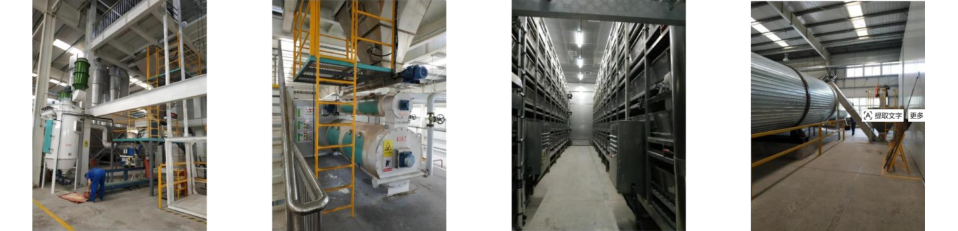
Figure 1 Live View of Constant‑Temperature Purified Fermentation Workshop and Automated Production Line

2.4 Substance Transformation during Fermentation
Raw Material Component | Role & Transformation | Transformation Product
Starch, saccharides | Easily digestible starch: converted into monosaccharides or disaccharides during pretreatment | Probiotics: converted into probiotic biomass such as yeast cells
Plant protein | Provide carbon and nitrogen sources for fermentation; serves as the main fermentation substrate | Modified protein: pre‑digested in vitro to improve protein utilization
Special components | Such as trace elements and growth factors, inducing the fermentation direction | Metabolites: nucleotides, yeast cell wall components, and other feed intake‑promoting substances

2.5 Protein Texturization
After fermentation, extrusion, and puffing, the spherical soybean protein is transformed from a dense globular structure into a loose fibrous structure, resembling the spatial organization and digestive characteristics of animal protein.
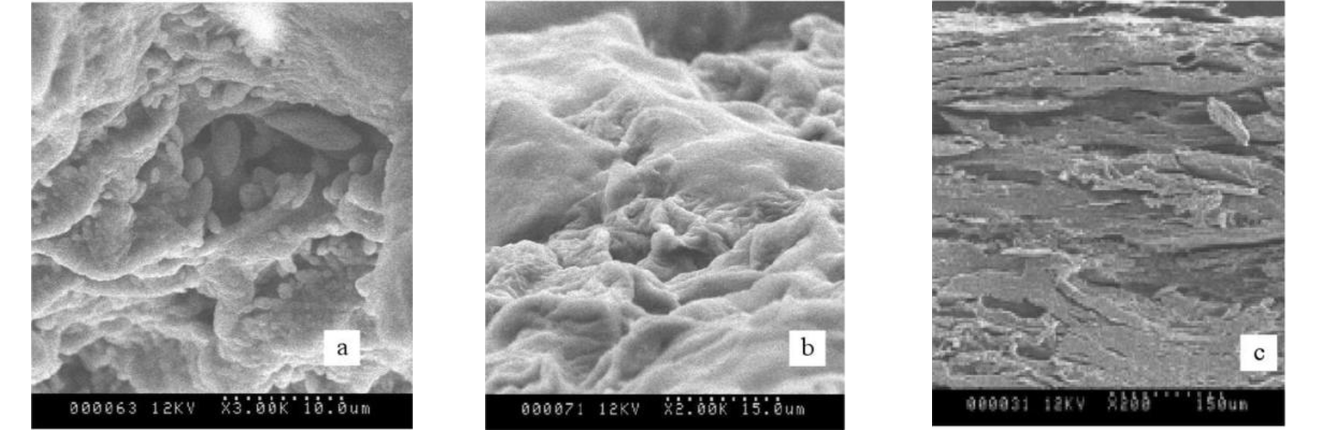
Figure 2 Product SEM Images (a, b, c) - Showing the protein fibrous structure

III. Core Advantages
The advantages of Sustar PeptiMax can be summarized in six aspects: high‑digestibility plant protein, dual fermentation, extremely low anti‑nutritional factors, animal‑like protein structure, improving gut health and immunity, and reducing formula cost. These are detailed below.

3.1 High‑Digestibility Plant Protein
Deep aerobic fermentation with Saccharomyces cerevisiae achieves in vitro pre‑digestion of protein, complemented by low‑temperature drying to minimize Maillard reactions. The product contains crude protein ≥55%, pepsin digestibility ≥95%, and available digestible protein 50.16%. Undigested protein entering the hindgut is significantly reduced, thereby decreasing abnormal fermentation and the production of ammonia‑like harmful substances. When used in aquafeeds, it also helps reduce protein discharge into water bodies.

3.2 Dual Fermentation: Plant Protein + Functional Yeast Culture
This is the fundamental difference from conventional fermented soybean meal. In addition to providing high‑digestibility plant protein, the product is also enriched with active yeast cells, β‑glucan, mannanoligosaccharides (MOS, mannan ≥0.20%), nucleotides, and small peptides. As a single ingredient, it simultaneously serves as both a "protein source" and a "functional additive," simplifying feed formulations and reducing overall costs.

3.3 Extremely Low Anti‑Nutritional Factors
The application bottleneck of soybean meal‑based ingredients lies in anti‑nutritional factors. Through the combined action of enzymatic hydrolysis and fermentation, this product degrades oligosaccharides and antigenic proteins. Trypsin inhibitor and lectin have both been tested as "not detected" by third‑party laboratories.
Anti‑Nutritional Factor | Indicator
Trypsin inhibitor (mg/g) | Not detected
Lectin (ppm) | Not detected
Stachyose + Raffinose + Sucrose (%) | < 0.50
β‑Conglycinin + Glycinin (%) | ≤ 2
The reduction of anti‑nutritional factors directly improves palatability and reduces the risk of allergic diarrhea in young animals, which is a prerequisite for increasing feed intake.

3.4 Animal‑Like Protein Structure with Excellent Digestive Properties
Through extrusion puffing, the globular soybean protein is modified into a loose fibrous structure, featuring good water‑holding capacity and abundant enzyme‑binding sites. Digestion and absorption rates tend to be synchronized, resulting in a more stable amino acid metabolic pool. The physical morphology of the digesta is improved, reducing mechanical damage to the intestinal mucosa.

3.5 Improved Gut Health and Immune Function
β‑Glucan stimulates the reticuloendothelial system and enhances the activity of macrophages; MOS interferes with the colonization of pathogenic bacteria; nucleotides and small peptides participate in intestinal development and repair. The benefits are reflected in improved villus development, enhanced mucosal integrity, proliferation of beneficial bacteria, reduced diarrhea incidence, increased survival rates, and alleviation of stress from weaning, pond transfer, and transportation. This product is particularly suitable for antibiotic‑free farming.

3.6 Reduced Formula Cost and Stable Supply
It can partially replace fishmeal, yeast hydrolysate, and premium fermented plant proteins, reducing formula costs while maintaining production performance. As a domestically produced product with full supply chain control, it offers stable supply, short lead times, and complete traceability throughout the entire production process.

IV. Product Specifications

4.1 Routine Parameters
Item | Indicator | Item | Indicator
Crude protein, % | ≥55.00 | Stachyose + raffinose + sucrose, % | < 0.50
Moisture, % | ≤12.00 | β‑Conglycinin + Glycinin, % | ≤ 2
Crude ash, % | ≤8.0 | Trypsin inhibitor, mg/g | Not detected
Crude fiber, % | ≤7.0 | Lectin, ppm | Not detected
Mannan, % | ≥0.20 | Digestible energy (pig), Kcal/kg | 3980
Crude fat, % | ≤1.50 | Metabolizable energy (pig), Kcal/kg | 3624
Pepsin digestibility, % | ≥95.00 | Net energy (pig), Kcal/kg | 2212

4.2 Amino Acid Composition
Amino Acid | Content (%) | Amino Acid | Content (%)
Methionine | 0.74 | Proline | 2.94
Cystine | 0.70 | Serine | 2.80
Leucine | 4.38 | Aspartic acid | 6.49
Threonine | 2.19 | Phenylalanine | 2.93
Valine | 2.69 | Alanine | 2.52
Isoleucine | 2.63 | Glycine | 2.39
Arginine | 3.93 | Glutamic acid | 10.32
Lysine | 3.54 | Histidine | 1.54
Tryptophan | 0.52 | Total amino acids | 53.25
Note: These data are from third‑party testing and are for reference only.

4.3 Minerals and Trace Elements
Element | Content | Element | Content
Calcium (Ca) | 0.29 % | Iron (Fe) | 190 mg/kg
Total phosphorus (P) | 0.76 % | Zinc (Zn) | 52 mg/kg
Potassium (K) | 2.4 % | Manganese (Mn) | 37 mg/kg
Magnesium (Mg) | 0.32 % | Copper (Cu) | 16 mg/kg
Sodium (Na) | 890 mg/kg | Sulfur (S) | 0.39 %
Note: Mineral data are from third‑party test reports; mercury, lead, cadmium, fluorine, and tin were all not detected.

4.4 Safety Parameters
Category | Test Result
Mycotoxins | Aflatoxin, zearalenone, deoxynivalenol (DON), T‑2 toxin, ochratoxin A – all not detected
Heavy metals | Mercury, lead, cadmium, fluorine, tin – not detected
Other harmful substances | Nitrite, cyanide, free gossypol, PCBs, BHC, DDT, hexachlorobenzene – all not detected
Microbiological | E. coli <3 MPN/g; mold 2.6*10² CFU/g; total bacterial count 6.9*10⁴ CFU/g; salmonella not detected

V. Comparison of Key Parameters with Fishmeal
Indicator | Fish meal | Sustar PeptiMax
Crude protein, % | 65 | ≥55
Non‑protein nitrogen, % | 15 (biogenic amines, inorganic nitrogen, etc.) | 4 (nucleic acids, fermentation‑derived nitrogenous metabolites)
Protein digestibility, % | 90 | ≥95
Anti‑Nutritional Factor | Histamine, putrescine, cadaverine,  gizzerosine, botulinum toxin, etc. | Trypsin inhibitor – not detected  Lectin – not detected  Oligosaccharides < 0.50%
Harmful microorganisms | Salmonella, shigella,  klebsiella pneumoniae, enterobacter cloacae, etc. | Salmonella – not detected
With higher digestibility and lower non‑protein nitrogen, this product can partially replace fishmeal while avoiding the risks associated with biogenic amines and pathogenic microorganisms.

VI. Functional Bioactive Substances
Through thorough aerobic fermentation, this product not only provides high‑digestibility plant protein but is also enriched with active yeast cells, β‑glucan, mannanoligosaccharides (MOS), yeast metabolites, and small peptides, delivering the dual value of “plant protein + functional yeast culture.”
Each kilogram of the product contains 15 billion yeast cells and their concentrated metabolites + 2.3% nucleotides + 0.8% short‑chain fatty acids + 0.2% mannan (with over 200 types of metabolites)
6.1 Feed Intake
Flavor‑enhancing nucleotides, umami amino acids, as well as fatty acids, esters, and aromatic compounds generated during fermentation, impart excellent palatability and feed attractability to the diet. In addition, the high digestibility accelerates the passage of digesta through the digestive tract, enhancing hunger sensation and thereby promoting feed intake in animals.
6.2 Digestibility
Enzymes and microorganisms synergistically break down macromolecular proteins and carbohydrates. The combined fermentation and extrusion treatment loosens the protein structure, exposing more digestive enzyme binding sites, thus improving digestion and utilization efficiency.
6.3 Gut Health
It improves intestinal villus development, promotes the proliferation of beneficial bacteria, reduces intestinal inflammation, and maintains the integrity of the intestinal mucosa, thereby enhancing the absorption efficiency of nutrients.
6.4 Immune Function
Its components such as β‑glucan, mannanoligosaccharides, and nucleotides activate innate immunity, enhance phagocytic cell activity, strengthen disease resistance, and alleviate stress responses, ultimately contributing to improved survival rates.

VII. Comparison with Premium Fermented Plant Proteins
Sustar PeptiMax can serve as an alternative to premium fermented plant protein products. The following comparison is based on the compositional data of premium fermented plant protein reported in public literature, and used for formulators’ reference.

7.1 Comparison of Key Components
Item | Premium Fermented Plant Protein | Sustar PeptiMax
Crude protein, % | 55.00 | ≥55.00
Crude fat, % | 2.50 | ≤1.50
Trypsin inhibitor | 1 mg/g | Not detected
Lectin | < 1 ppm | Not detected
Oligosaccharides, % | 1.0 | < 0.50 (stachyose + raffinose + sucrose)
Functional yeast components | — | Active yeast cells, β‑glucan,  mannanoligosaccharides (MOS), yeast metabolites

7.2 Comparison of Amino Acid Compositions (per 100 g protein)
Amino Acid | Premium Fermented Plant Protein | Sustar PeptiMax
Lysine | 6.2 | 6.44
Leucine | 7.8 | 7.96
Phenylalanine | 5.0 | 5.33
Threonine | 4.0 | 3.98
Isoleucine | 4.8 | 4.78
Valine | 5.2 | 4.89
Methionine | 1.5 | 1.35
Cystine | 1.5 | 1.27
Tryptophan | 1.3 | 0.95
Note: The amino acid values for Sustar PeptiMax are calculated from third‑party test results of amino acid content, converted to per 100 g protein based on a crude protein level of 55%. The major limiting amino acids (lysine, leucine, threonine, isoleucine, etc.) are comparable to or slightly higher than those of the premium product; methionine and tryptophan are slightly lower and can be supplemented with crystalline amino acids in formulation.
Item | Premium Fermented Plant Protein | Sustar PeptiMax
Product type | Fermented plant protein | Fermented plant protein + yeast culture
Protein source | Plant protein | Plant protein + yeast protein
Functional components | Fermentation‑derived active ingredients | Active yeast cells, β‑glucan,  mannanoligosaccharides, yeast metabolites
Note: The above table provides an objective comparison of product characteristics and supply methods, and does not constitute an evaluation of the efficacy of any brand. Actual application results should be verified through practical formulation and feeding trials.

VIII. Recommended Inclusion Rates and Substitution Strategies

8.1 Recommended Inclusion Rates
Category | Recommended Inclusion Rate
Piglet feed | 3-5%
Poultry feed | 1-3%
Sow feed, grower‑finisher pig feed | 5%
Fish and shrimp feed (aquafeed) | 3-5%
Calf feed | 0.5-1.5%

8.2 Substitution Strategies
Target for Replacement | Recommended Inclusion Rate / Ratio | Description
Fishmeal | 2–5% | It can replace a portion of fishmeal in various formulations to maintain growth performance
Yeast hydrolysate | PeptiMax : yeast hydrolysate = 5 : 1 | Reduces ingredient costs while maintaining immune‑enhancing effects
Premium fermented plant proteins | Replaces at a ratio of 1:1, subject to adjustments based on formulation | A localized alternative that balances production performance, supply stability, and cost advantages

8.3 Product Specifications
Packaging Specification: 25 kg/bag
Shelf Life: 12 months from the date of production
Storage Conditions: Stored in a sealed, well‑ventilated, and dry place; avoid direct sunlight and moisture. It is recommended to store it on pallets, away from walls and floors. After opening the packaging bag, reseal promptly and use it as soon as possible.

